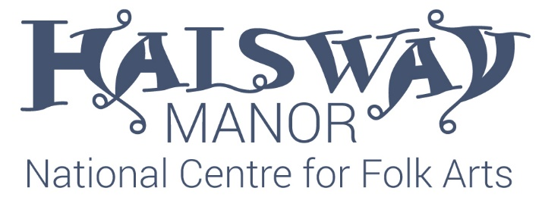
The Paul Sartin Bursaries are awarded in his memory to cover 50% of the cost of a weekend or week-long course at Halsway Manor for anyone aged 18 – 30 whose financial circumstances would otherwise prevent them from attending.
Bursaries are limited and are awarded a first-come, first-served basis to individuals who fulfil the criteria. Bursaries can be used for any course, providing there is a place available.
Applicants will be selected by the CEO, Crispian Cook, and the Programme Manager, Rachel Wilkinson.
If you would like to be considered for a bursary, please complete the form below and email it to chiefexec@halswaymanor.org.uk
We may contact you for an informal chat or more information, and you will hear from us whether or not we are able to offer you a bursary.
Name
Address
Email address
Age

Please could you tell us a little about your circumstances and why you are applying for a bursary.
(Max 300 words)

