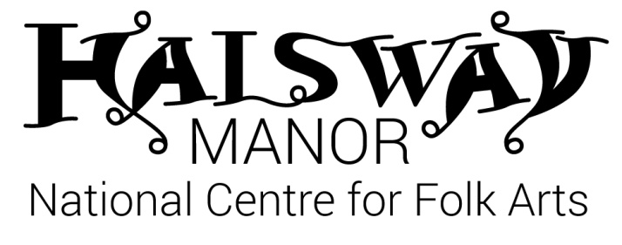
Halsway Young Folk - Introduction 11th– 15th April, 2022
For young people aged 11-16
About the young person attending:

First name ________________________________ Surname _____________________________________

Date of birth ______________________________ Gender M / F

School year _____

School ________________________________________________________________________________________

Home address _______________________________________________________________________________

_____________________________________________ Postcode ____________________________________

Contact telephone number of parent/carer ______________________________________________

Contact email of parent/carer _____________________________________________________________

Please tell us about any music/dance experience you have:

Instruments/dance styles _____________________________________________________ ______

_______________________________________________________________________________________________

Grades/qualifications/time played for ___________________________________________________

_______________________________________________________________________________________________

Extracurricular groups/troupes/bands/orchestras attended _________________________

_______________________________________________________________________________________________

Dietary requirements/food allergies _____________________________________________________

Special access requirements (eg wheelchair user) ______________________________________

Medical conditions _________________________________________________________________________
Please see lead/pastoral tutor upon arrival to pass on further information/medication.

Other relevant information about the young person attending ________________________

_______________________________________________________________________________________________

Requests for room shares (please note that while we will try to fulfil these requests we cannot always guarantee them).

______________________________________________________________________________________________

Please indicate if you would like to be considered YES / NO
for a bursary (we will contact you to discuss this)

Emergency Contact Details

Please provide at least 2 people we can contact in case of an emergency.

First contact
Name: ___________________________________________________
Telephone: ___________________________________________________
Email: ___________________________________________________
Relationship to young person: ___________________________________________________

Second contact
Name: ___________________________________________________
Telephone: ___________________________________________________
Email: ___________________________________________________
Relationship to young person: ___________________________________________________

Parent or Guardian to complete

First name ________________________________ Surname ________________________________

Relationship to young person _________________________________________________________

As the parent/guardian I am satisfied with the details supplied regarding all Young Folk activities and agree for my child to take part in them.
[ ] In the event of a minor accident, I agree for First Aid to be
administered by a qualified First Aider.
[ ] I agree to my child being taken to hospital, or to being seen by the
nearest doctor available should an emergency arise.
[ ] I give my permission for my son/daughter to be taken off site for local
activities.
[ ] I give my consent for video/photos to be taken of my child for
monitoring / evaluation purposes.
[ ] I give my permission for videos/photos of my child to be used
for publicity purposes incl Halsway Manor website, facebook
and other 3rd party agencies (e.g. Sidmouth Folk Festival, Arts Council England)
Signed ……………………………………………………. Date …………………………………..

Please return to office@halswaymanor.org.uk or post to: Halsway Manor, Halsway Lane, near Crowcombe, Somerset. TA4 4BD.

