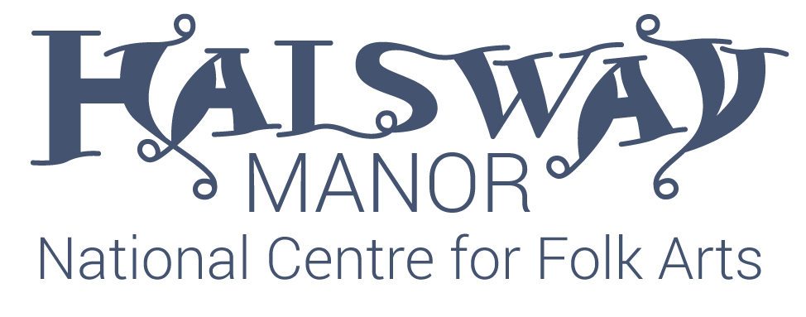

Halsway Lane, Crowcombe, Somerset TA4 4BD
www.halswaymanor.org.uk
JOB DESCRIPTION

Job Title: Bookings Administrator
Reports to: Chief Executive
Location: Halsway Manor, Crowcombe, Somerset
Pay: £19,500
Working Pattern: Full time (37.5 hours, 7.5 per day excl breaks). 28 days paid holiday including bank holidays.

Halsway Manor – National Centre for Folk Art is a charity and the only residential centre in the world concentrating on the varied folk heritage of England. Set in six beautiful acres of gardens and grounds and unique in the UK it hosts over 345 days of residential and outreach activity every year covering all facets of folk arts from instrumental music, song and dance to traditional storytelling, crafts and instrument making. has a warm and welcoming atmosphere, a range of comfortable bedrooms, great food and a beautiful panelled bar.
We are seeking a Bookings Administrator to manage telephone, online and person to person bookings for courses and events at Halsway Manor. Working as part of small team, this position will also play an active role in ensuring visitors enquiries are dealt with and dealing with day to day office support and administration.

Key Responsibilities

- Dealing with telephone, internet and face to face bookings including taking and following up payments and enquiries using Patronbase software.
- Ensuring course payments are taken and all information is sent out to artists and participants.
- Spending time front of house dealing with visitor enquiries.
- Be a strong advocate for the business.
- Managing patron databases, ensuring they are up to date, correct and GDPR compliant.
- Creating relevant paperwork and forms for staff and visitors including course information, menus and other information.
- Acting as Duty Manager when required.
- Dealing with our partnership booking organisations.
- Being first line contact point for the charity and distributing enquires appropriately.
- Managing day to day office tasks.
- Working closely with Finance Manager on membership database and communication.
- Reconciling cash and supervising any cash payments (for example, floats for events)
- Working with marketing to distribute course information and promotion.
- Communicating information to house staff.
- Working with Communication Manager to ensure website and events information is up to date.
- Be an active member of the management team.
- Other reasonable tasks agreed with Chief Executive.
Person specification
Essential
Good level of secondary education
Relevant customer facing experience
Ability to multitask and to organise workload efficiently
Excellent administration skills
Excellent time management skills
Experience in promoting services and products
Clear, confident communicator with a polite and patient telephone manner
Computer literate –working knowledge of Microsoft software
Excellent customer service skills –understanding the needs of visitors
Flexible and positive working attitude with the ability to accept supervision and direction
Ability to follow instructions/protocol consistently
Proactive, reliable and conscientious
Desirable
Relevant degree
Experience working in similar charity role.
Experience using online bookings system.
Working in an arts organisation.
Passionate about music, education and arts.
To apply please send your CV to the Chief Executive, Crispian Cook chiefexec@halswaymanor.org.uk with a short covering letter outlining why you want this position by 12noon on 5th April 2021.
No applications will be accepted without covering letter and CV or through Facebook.

