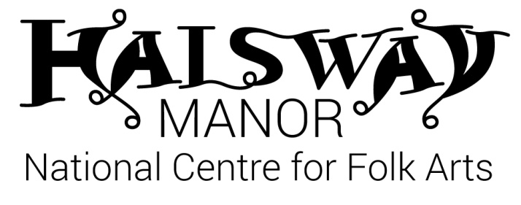
Halsway Young Folk – Advanced
Mon 24 – Fri 28 August, 2020

Application Form

We aim to allocate places on a first-come, first-served basis to applicants of the relevant age and experience / ability level.

A deposit payment of £60 is required with this application, refundable in full* if your application is not accepted for any reason.
About You

First name ______________________________________________________ Surname ____________________________________________

Date of birth ____________________________________________________ Gender M / F

Address ___________________________________________________________________________________________________________________

_____________________________________________________________________________________________________________________________

______________________________________________________________________ Postcode ____________________________________________

Contact telephone number (inc code) ___________________________________________________________________________________

Contact email ______________________________________________________________________________________________________________

School / college ____________________________________________________________________________________________________________

Please tell us about your skills:

Instruments (including voice) ___________________________________________________________________________________________

Grades / qualifications / years played ___________________________________________________________________________________

_______________________________________________________________________________________________________________________________

_______________________________________________________________________________________________________________________________

Extracurricular groups / bands / orchestras attended (including previous HYF courses) ___________________________

_______________________________________________________________________________________________________________________________

_______________________________________________________________________________________________________________________________

*Special dietary requirements _____________________________________________________________________________________________

*Special access requirements (eg wheelchair user) _____________________________________________________________________

*Please feel free to contact us to discuss in more detail.
Are you planning to attend with friends / siblings who you would like to share a room with? If so, please let us know names here:

_______________________________________________________________________________________________________________________________

Emergency Contact Details

Please provide at least 2 people we can contact in case of an emergency.

First contact
Name: ____________________________________________
Telephone: ____________________________________________
Email: ____________________________________________
Relationship to student: ____________________________________________

Second contact
Name: ____________________________________________
Telephone: ____________________________________________
Email: ____________________________________________
Relationship to student: ____________________________________________

Parent or Guardian to complete the section below for under 18s

First name ____________________________________ Surname ___________________________________________

Relationship to student _________________________________________________________________________

As the parent/guardian I am satisfied with the details supplied regarding all Young Folk activities and agree for my child to take part in them.
[ ] In the event of a minor accident, I agree for First Aid to be administered by a qualified First Aide
[ ] I agree to my child being taken to hospital, or to being seen by the nearest doctor available should an emergency arise.
[ ] I give my permission for my son/daughter to be taken off site for local activities.
[ ] I give my consent for video/photos to be taken of my child for monitoring / evaluation purposes.
[ ] I give my permission for videos/photos of my child to be used for publicity purposes including Halsway Manor website, Facebook and other 3rd party agencies (e.g. Sidmouth Folk Festival, Arts Council England)

Signed ………………………………..................................……………………. Date …………………………………..
Please return to office@halswaymanor.co.uk or post to:
Halsway Manor, Halsway Lane, near Crowcombe, Somerset. TA4 4BD.
Please include a deposit of £60*; cheque payable to ‘Halsway Manor Society’ or telephone 01984 618274 ext 1 to make a card payment.
*We will refund this payment to you in full if your application is not successful; if you wish to cancel this booking we will retain an admin fee of £25 and refund to you the remaining £35.

This information will be shared with the course leaders for Contractual purposes only.

