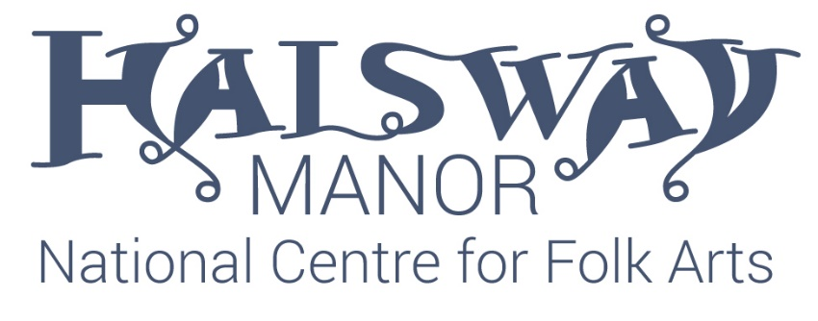
Incubator Bursary Application Form
Name:
Email:
Address:
Mobile:
Please describe what you do.
Please tell us about your professional aims and objectives.
Please describe the project you are applying for.
Please tell us how you would use the money and residential time.

Please tell us how you think working with Halsway Manor would help you.
All applications should be emailed to Crispian Cook, Chief Executive, Halsway Manor chiefexec@halswaymanor.org.uk and received by 5pm on the 31st December 2019.

