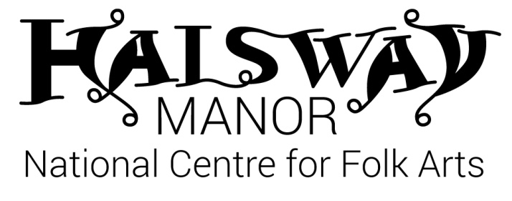
Halsway Manor Society Trustees
New Trustees are being sought to join Halsway Manor – National Centre for Folk Arts, the only residential centre in the world concentrating on the varied folk heritage of England. This unique, financially self-supporting charity runs a year-round programme of residential courses as well as a wide-reaching creative learning and artist development programme from its 27 bedroom Grade II* listed manor house in one of the most beautiful regions of the UK.
Having recently undergone a £600,000 restoration funded by the Heritage Lottery Fund, Country Houses Foundation and private donations the charity is going from strength to strength and currently managing its next exciting development project to provide more space to meet the ever increasing demand.
Board Members help to increase the visibility and profile of the charity locally, nationally and internationally and ensure it has the capacity and skills to deliver the next phase of its artistic and commercial plans.
Board membership is voluntary and unpaid and trustees are expected to attend four board meetings per year as well as other activities when appropriate. New members are particularly sought with expertise in the following areas:
- Legal
- Human resources
- Fundraising

About us
Halsway Manor is a charity nestling in the Quantock Hills - Area of Outstanding Natural Beauty, it hosts courses, events and projects in a unique and magical setting. Set in six beautiful acres of gardens and grounds the manor has a warm and welcoming atmosphere, a range of comfortable bedrooms with full board accommodation, workshop spaces and spaces to relax and socialise.
For over 50 years Halsway Manor has hosted unique experiences and inspired thousands of people to experience the diverse dance, song, music and art found in our green and pleasant lands. Unique in the UK it hosts over 340 days of residential and outreach activity every year covering all facets of folk arts from instrumental music, song and dance to traditional storytelling, crafts and instrument making. We are committed to excellence and opportunity for all with a broad programme that covers amateur exploration, professional development, the creation of new work and stewardship of our heritage.
About the role
Trustee Role Description
- To contribute actively to the board of trustees;
- To ensure that Halsway Manor Society complies with its Memorandum and Articles of Association, charity law, company law and any other relevant legislation or regulations;
- To ensure that Halsway Manor Society pursues its object as defined in the Memorandum and Articles;
- To ensure accountability to funders and stakeholders for the organisation’s performance;
- To exemplify the values of the organisation by:
- attending regularly and being actively involved in decision making;
- acting as an advocate for Halsway Manor Society by forging and maintaining links outside the organisation;
- engaging willingly and actively with Halsway Manor Society’s programme, employees and audiences;
- actively suggesting and implementing any ideas for the efficient operation of the society;

Person specification
- Demonstrable commitment to the work and objects of Halsway Manor
- Knowledge and expertise in one or more if the following areas:
Legal
Human resources
Fundraising
Health and safety
Business management
Venue management
- Excellent communication skills and teamwork
- Understanding and acceptance of the legal duties, responsibilities and liabilities of trusteeship
- Have the ability to contribute to future policy and strategic direction
Time commitment
- Quarterly trustee meetings
- Other sub-committee meetings as necessary
- Attending and helping to host Halsway Manor events and other engagements
- Additional time to study papers and give ad hoc support to the CEO as necessary
Term of Office
Trustees are appointed for a period of 3 years which can be renewed. Trustees must be members of the society and voted in at the AGM or co-opted until that time if appropriate.
Remuneration
Trustees do not receive remuneration, but reasonable expenses for attending meetings are paid there might also be the possibility of staying at Halsway before or after meetings.
Prospective candidates should send an application form to Julie Williams, Chair of Halsway Manor Society chair.halswaymanor@gmail.com
For an informal chat about Halsway Manor please telephone Crispian Cook, Chief Executive on 01984 618274

