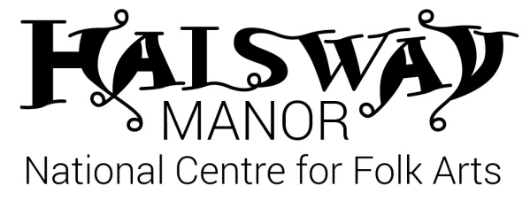
Board of Trustees APPLICATION FORM
Name:

Phone number: Home: Mobile:

Email:

Address:

Main field of employment experience e.g. education, engineering.

Other specialist/relevant experience or qualifications

Please explain briefly why you are interested in becoming a trustee of the Halsway Manor Society?

Do you have any specific interests or expertise relevant to Halsway Manor especially in the areas particularly sought?

Are there any areas of work of the organisation you have a particular interest in and/or would like to become involved in?

A diverse board is able to reflect and support the delivery of an organisation’s mission. Do you have specific patronage, social or family experience or background that will help us to better support the goals of the organisation?

Halsway Manor Society Board of Directors

Skills Audit for Potential Board Members

This document should be completed by all Potential Board members, using a rating scale of 1 to 4, with 1 being no knowledge or expertise to 4 being extensive knowledge, expertise and experience in a particular field.

Name

Skills/knowledge, expertise/qualifications | Rating scale  1 - 4 | Any other relevant info eg Where gained: Voluntary (V), Commercial (C) or Statutory (S) sector. Role in the company/organisation.
Directorship

Leadership

Board/committee experience

Facilitating meetings

Administration/secretarial

Conflict resolution

Change management

Finance

Income generation/fundraising

Campaigning

Education/teaching

Academic writing/research

IT/systems

Legal

Skills/knowledge, expertise/qualifications | Rating scale  1 - 4 | Any other relevant info eg Where gained: Voluntary (V), Commercial (C) or Statutory (S) sector. Role in the company/organisation.
Team development

Listening & communication

People management/Public relations
Marketing/selling

Project management

Architectural/surveying

Property maintenance

Mechanical/engineering

Understanding of the Society’s aims

Service user/beneficiary of Halsway Manor Society

Prospective candidates should send an application form to Julie Williams, Chair of Halsway Manor Society chair.halswaymanor@gmail.com

