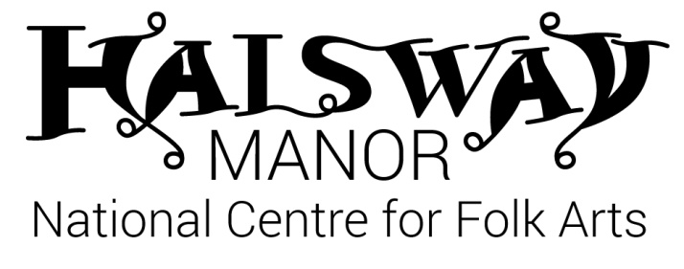
NORTHUMBRIAN SMALL PIPES TASTER DAY
Tutor – Francis Wood

Saturday 7 March, 10am-4pm

PROGRAMME

The day will cover:
The use of bellows in the most relaxed and efficient way
Principles of ‘closed fingering’
Coordinating bag and bellows arms to sustain a steady pressure
Drone tuning
Discussion of the instrument’s history and development

Timings:

10am Workshop
11am Tea/Coffee
11.15am Workshop
12.30pm Bar Open
1pm Lunch
2pm Workshop
4pm Tea
Optional:
6.30pm Dinner
8pm Northumbrian Small Pipes Concert

