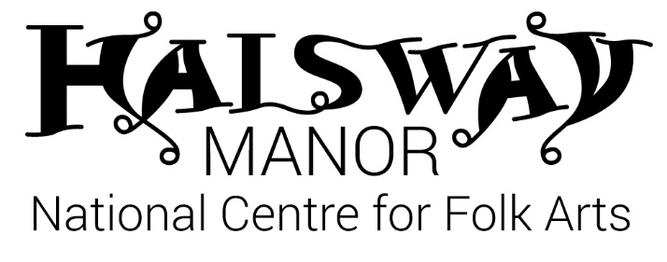
Piano Accordion Weekend
Friday 7 – Sunday 9 June 2019
With Paul Hutchinson, Murray Grainger, Rachel Bell & Jane Ward

FRIDAY
4.00 onwards | ARRIVALS, CHECK-IN, TEA / COFFEE
6.30 | DINNER
8.00 | WELCOME | Groups A, B & C and all tutors together in the Long Room |  | Beginners with Jane in the Library
SATURDAY |  | GROUP A  (Long room) | GROUP B  (Bar) | GROUP C  (Mews) | BEGINNERS  (Library)
8.00 | BREAKFAST
9.00-10.30 | SESSION 1 | Paul | Murray | Rachel | Jane
10.30-11.00 | COFFEE
11.00-12.30 | SESSION 2 | Paul | Murray | Rachel | Jane
1.00-2.00 | LUNCH
2.00-3.30 | SESSION 3 | Rachel | Paul | Murray | Jane
3.30-4.00 | TEA
4.00-5.30 | SESSION 4 | Rachel | Paul | Murray | Jane
6.00PM | DINNER
8.00PM | TUTORS CONCERT
SUNDAY |  | GROUP A  (Long room) | GROUP B  (Bar) | GROUP C  (Mews) | BEGINNERS  (Library)
8.00 | BREAKFAST
9.00-10.30 | SESSION 5 | Murray | Rachel | Paul | Jane
10.30-11.00 | COFFEE
11.00-12.30 | SESSION 6 | Murray | Rachel | Paul | Jane
1.00-2.00 | LUNCH
2.00-3.45 | FINAL SESSION | A, B & C: LARGE GROUP CONCERT/SHARING |  | Beginners: listen or have a final workshop with Jane
4.00 | CREAM TEA & FAREWELLS!

