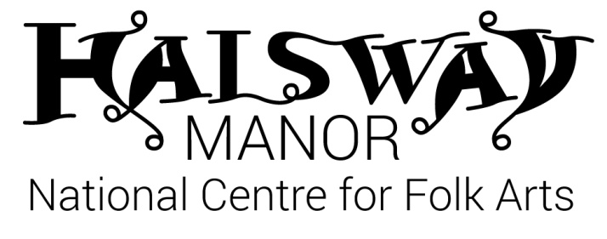
Spring Young Folk Monday 3 Apr — Friday 7 Apr, 2017
Application Form

About You

First name ________________________________ Surname _________________________________

Date of birth ______________________________ Gender M / F

Address ___________________________________________________________________________________

_____________________________________________________________________________________________

_____________________________________________ Postcode _________________________________

Contact telephone number (inc code) _________________________________________________

Contact email ____________________________________________________________________________

School ____________________________________________________________________________________

Please tick which programme strand you are joining (choose one) and tell us about your skills:

Music [ ] Instruments _____________________________________________________

Dance [ ] Styles ____________________________________________________________

Grades / qualifications _________________________________________________________________

____________________________________________________________________________________________

Extracurricular groups / troupes / bands / orchestras attended __________________

____________________________________________________________________________________________

____________________________________________________________________________________________

Special dietary requirements __________________________________________________________

Special access requirements (eg wheelchair user) ___________________________________

Please indicate if you would like to be considered YES / NO
for a bursary (we will contact you to discuss this)

Emergency Contact Details

Please provide at least 2 people we can contact in case of an emergency.

First contact
Name: ____________________________________________
Telephone: ____________________________________________
Email: ____________________________________________
Relationship to young person: ____________________________________________

Second contact
Name: ____________________________________________
Telephone: ____________________________________________
Email: ____________________________________________
Relationship to young person: ____________________________________________

Parent or Guardian to complete for under 18s

First name ________________________________ Surname ________________________________

Relationship to young person _________________________________________________________

As the parent/guardian I am satisfied with the details supplied regarding all Young Folk activities and agree for my child to take part in them.
[ ] In the event of a minor accident, I agree for First Aid to be
administered by a qualified First Aider.
[ ] I agree to my child being taken to hospital, or to being seen by the
nearest doctor available should an emergency arise.
[ ] I give my permission for my son/daughter to be taken off site for local
activities.
[ ] I give my consent for video/photos to be taken of my child for
monitoring / evaluation purposes.
[ ] I give my permission for videos/photos of my child to be used
for publicity purposes incl Halsway Manor website, facebook
and other 3rd party agencies (e.g. Sidmouth Folk Festival, Arts Council England)

Signed ……………………………………………………. Date …………………………………..

Please return to office@halswaymanor.co.uk or post to: Halsway Manor, Halsway Lane, near Crowcombe, Somerset. TA4 4BD.

