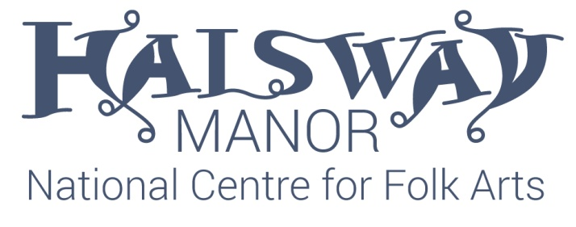
Job description
Post: Assistant Chef
Responsible to: Chef/Operations Manager
Duration: 10 hours per week
Halsway Manor – National Centre for Folk Arts are seeking to recruit a Assistant Chef to work as part of a small team for this unique charity situated in a beautiful manor house within an Area of Outstanding Natural Beauty.
10 hours per week will be spent working in the kitchen preparing meals with the guidance of our two chefs. There is a possibility for more hours working as part of the house team, cleaning, servicing rooms, serving etc if required although this will be at the house keeper pay rate.
Some experience of working in a kitchen is essential although training will be given.
Duties
Catering | Cooking and preparing meals for guests.
Emergencies | To assist with evacuation procedure and first aid response in an emergency. Training is provided.
Room changes | Ensuring rooms are cleaned and changed ready for guests.
Cleaning and tidying | Ensuring the premises are clean and tidy at all times.
Meal time duties | Ensuring meals are served as required, tables are set and put away, washing up and any other tasks are completed as required.
Laundry | Undertake laundry duties as required.
Refreshments | Ensuring guests have tea and coffee and fresh water etc as required.
Bar work | Bar staff duties may occasionally be required. Training is provided
Health and safety | You have a duty to take care of their own health and safety and that of others who may be affected by your actions at work. Workers must co-operate with employers and co-workers to help everyone meet their legal requirements. Any issues must be reported to your line manager. You must review, understand and sign a copy of the staff handbook.
Training | Training or all aspects of the job will be provided including your Food Hygine Certificate. You must attend in house training courses and sessions as required.
Other | Other tasks that may be required which are compatible with the job. You may want to develop skills and experience in other aspects of the operation and these can be agreed through discussion with the Operations Manager.

Key criteria | Essential | Desirable
Qualifications
Good level of general education | E
Experience / Knowledge / Skills / Abilities
Experience of working in a housekeeping role |  | D
Experience of working in a catering environment |  | D
Personal attributes
Honesty, integrity, tenacity and openness. | E
Inspires trust and confidence and handles confidential information with discretion. | E
Positive attitude, good social skills and respect for all people. | E
Customer focused and friendly | E
Willingness to undertake training | E
Other
Driving licence and/or ability to travel to work reliably. | E

Applications
To apply for this position please send your CV including two referees to:
Crispian Cook chiefexec@halswaymanor.org.uk Applications should be received by 28/8/17
Conditions of Employment

Pay: £9.25 for 10 hours in the kitchen and £7.50 for any subsequent house shifts.

Hours of work: 10 hours per week to be planned in consultation with the Chef and Operations Manager.

