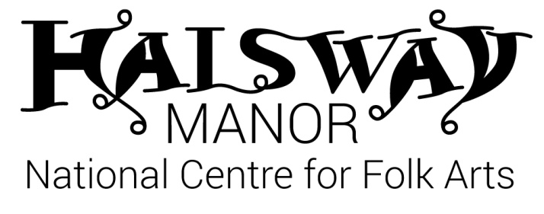
Halsway Young Folk – Intermediate:
Monday 30 July — Saturday 4 August, 2018

Application Form

We aim to allocate places on a first-come, first-served basis to applicants of the relevant age (13-18) and experience level (intermediate; you’ll need to be a proficient musician or singer - equivalent to grade 4+ - with some experience of folk music. Not sure? Get in touch).

A deposit payment of £60 is required with this application, refundable in full* if your application is not accepted for any reason.

About You

First name ___________________________________ Surname ____________________________________________

Date of birth ______________________________ Gender M / F

Address _______________________________________________________________________________________________

________________________________________________________________________________________________________

_____________________________________________ Postcode ___________________________________________

Contact telephone number (inc code) __________________________________________________________________

Contact email _________________________________________________________________________________________

School ________________________________________________________________________________________________

Please tell us about your skills:

Instruments (including voice) _________________________________________________________________________

Grades / qualifications ________________________________________________________________________________

_______________________________________________________________________________________________________

Extracurricular groups / troupes / bands / orchestras attended _________________________________________

_______________________________________________________________________________________________________

______________________________________________________________________________________________________

Special dietary requirements _________________________________________________________________________

Special access requirements (eg wheelchair user) ____________________________________________________

Emergency Contact Details

Please provide at least 2 people we can contact in case of an emergency.

First contact
Name: ____________________________________________
Telephone: ____________________________________________
Email: ____________________________________________
Relationship to young person: ____________________________________________

Second contact
Name: ____________________________________________
Telephone: ____________________________________________
Email: ____________________________________________
Relationship to young person: ____________________________________________

Parent or Guardian to complete for under 18s

First name ____________________________________ Surname ___________________________________________

Relationship to young person _________________________________________________________________________

As the parent/guardian I am satisfied with the details supplied regarding all Young Folk activities and agree for my child to take part in them.
[ ] In the event of a minor accident, I agree for First Aid to be administered by a qualified First Aide
[ ] I agree to my child being taken to hospital, or to being seen by the nearest doctor available should an emergency arise.
[ ] I give my permission for my son/daughter to be taken off site for local activities.
[ ] I give my consent for video/photos to be taken of my child for monitoring / evaluation purposes.
[ ] I give my permission for videos/photos of my child to be used for publicity purposes including Halsway Manor website, facebook and other 3rd party agencies (e.g. Sidmouth Folk Festival, Arts Council England)

Signed ………………………………..................................……………………. Date …………………………………..
Please return to office@halswaymanor.co.uk or post to:
Halsway Manor, Halsway Lane, near Crowcombe, Somerset. TA4 4BD.
Please include a deposit of £60*; cheque payable to ‘Halsway Manor Society’ or telephone 01984 618274 ext 1 to make a card payment.
*We will refund this payment to you in full if your application is not successful; if you wish to cancel this booking we will retain an admin fee of £25 and refund to you the remaining £35.

