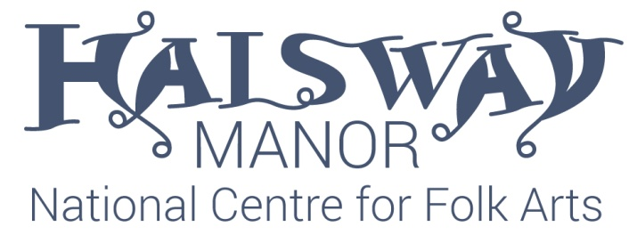

Halsway Manor Society Ltd - Notice of Meeting

NOTICE IS HEREBY GIVEN that the 52nd ANNUAL GENERAL MEETING of Halsway Manor Society Ltd, will be held at Halsway Manor, Crowcombe, Somerset, TA4 4BD, at 11.00 am Monday 16th October 2017 to transact the business which is set out in the Agenda shown on this document.

Voting at the General Meeting:

Members are entitled to vote on any question at any General Meeting and voting is normally conducted by a show of hands with each member present having one vote.

However, if a poll is called for, by either the Chairman, or by three or more members present, then proxy votes are also included with the votes of those present, in deciding the result of the poll.

Proxy Votes
Any member entitled to attend and vote may appoint another person (only one, whether a member or not) to attend and vote instead of him (Usually a Chairman of the meeting acts as your proxy). A proxy form is to be found at the end of this document and if you wish to appoint a proxy, the form must be returned to The Company Secretary at Halsway Manor, to arrive no later than first post on Monday 9th October 2017.

Notice is hereby given that three nominations to fill the vacancies on the Board were received by 30th August 2017. Details of each candidate are shown on page 2.

Notice is hereby given that the register of members will remain closed to new members until Tuesday 17th October 2017.

Notice is hereby given that a complete version of the Statutory Accounts is available online at www.halswaymanor.org.uk or by contacting the office at the above address.

Kathryn Searle
Company Secretary of Halsway Manor Society Ltd 18th September 2017
Nominations received for election to the Board of Directors at the AGM 2017

Mrs Bernie Dennis
My working life has been in education, most recently as a headteacher and music teacher so I have brought a variety of skills to the board including strategic planning; policy-making; objective-setting; financial management and working to tight deadlines.
Music has always been a very important part of my life –I sing, play the piano and piano accordion. Until recently, I ran two popular and vibrant community choirs at Bridgwater Arts Centre and performed around the country with the No.1 Ladies Accordion Orchestra.
These are exciting times for Halsway Manor with the restoration project and the constantly evolving programme of high quality courses. I believe that the future of Halsway depends on providing opportunities for young people and adults to become involved in the folk arts and to be able to develop their skills in a centre of excellence. I feel that my background and experience will benefit both of these aspects, and in particular the education strand.

Stephen Earwicker
I have been involved in folk dance & music most of my life, joining my first morris team, Farnborough Morris, in 1975. My folk interests & activities are fairly broad and include: Cotswold Morris, Rapper, Appalachian, Step Clog, & English Stepping; playing melodeon & percussion in English ceilidh bands; playing melodeon as band leader for a NW Morris side; performing Sea Shanties with The Wareham Whalers (this summer at Paimpol Festival in Brittany); conducting a West Gallery Choir & Band – The Purbeck Village Quire.
Outside the folk world my working life was spent in the NHS as a GP and manager with senior roles in one of the Nottingham PCTs. I am a Trustee & Board Secretary for The Kimmeridge Trust which has completed an HLF-funded new build fossil museum & village hall in Dorset. The Etches Collection has achieved international recognition since its opening in Oct 2016.

Julie Williams
I have been on the Board of Directors for three years and during that time, I have served as Vice-Chair and Chair of the Board. I have one more year as Chair before I must either stand down from the post or put myself forward for another three-year term. The right decision will become evident as the year progresses, but what I want now is to remain as an elected member of the Board so that I can fulfil my first full term of office. This has been a challenging and difficult role at times but also immensely rewarding in being able to help move Halsway Manor Society in the right direction to preserve its future. This work is only just coming to fruition and I would like to see it through to a more functional stage. I am therefore putting myself forward for re-election to serve another three-year term as a member of Halsway Board.

Three nominations were received by Wednesday 30th August 2017 to fill the vacant places. Gareth Kiddier and Roger Phipps elected not to stand for re-election. There is not a requirement for an election and all nominees will be able to take up a place on the Board following the AGM on Monday 16th October 2017.

Kathryn Searle
Company Secretary of Halsway Manor Society Ltd

Agenda for Halsway Manor Society Ltd. 52nd Annual General Meeting
to be held at 11.00 am on Monday 16th October 2017
at Halsway Manor, Crowcombe, Somerset, TA4 4BD.

Registered Charity No 247230 - Company No. 849615

1. Apologies for Absence

2. Minutes of the Annual General Meeting 2016

3. Matters Arising

4. Annual Report – available online

5. Annual Accounts – available online

6. Election of Board Members

7. Appointment of Albert Goodman LLP of Taunton as Auditors for 2017/18 and to authorise the Board to set the level of their fees

8. Any Other Business (By Leave)

Halsway Manor Society Ltd

Registered Charity No 247230 - Company No. 849615

I ……………………………………………………………..
(BLOCK LETTERS PLEASE)

Hereby appoint a) The Chairman of the meeting

Or b)…………...……………………………………………

(BLOCK LETTERS PLEASE)

To act as my proxy at the 2017 AGM, and exercise my vote as indicated below.
I declare that I will not be attending the AGM in person.

Signed………………………...................................................Date……………………….

Resolution | Details Of Resolution | FOR Resolution | AGAINST Resolution | ABSTAIN  to vote
1 | Adoption of the Annual Report
2 | Adoption of the Annual Accounts
3 | Appointment of Auditors  Albert Goodman LLP

1. To indicate your vote tick only ONE box opposite each resolution

If you fail to tick a box, no vote will be recorded for that resolution

2. To exercise your proxy vote, the completed form must be returned to:-
The Company Secretary, Halsway Manor Society Ltd,
Halsway Manor, Crowcombe, Somerset, TA4 4BD,
to arrive no later than first post on Monday 9th October 2017 or by email to the Company Secretary via email address: accounts@halswaymanor.org.uk

The envelope should be marked “Proxy Vote” in the top left hand corner.

