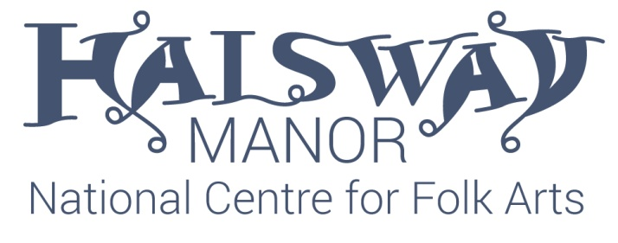
Halsway Manor D/G Melodeon Weekend
Anne Niepold, Andy Cutting, Hazel Askew
Fri 26 – Sun 28 May 2017
This programme is provisional and may be adapted to suit the group!
Music will not be sent out in advance for this course.
Friday:
4pm onwards Check in
6.30pm Dinner
8pm After dinner welcome session with Anne & Andy
Saturday:
8.30am Breakfast
9.30am-12.30pm Workshop 1
Hazel Beginners / Anne Intermediate / Andy Advanced
1pm Lunch
2pm-5pm Workshop 2 (including break for tea/coffee)
Andy Beginners / Hazel Intermediate / Anne Advanced
6pm Dinner
8pm Tutors’ Concert
Sunday:
9.30am-12.30pm Workshop 3 (including break for tea/coffee)
Anne Beginners / Andy Intermediate / Hazel Advanced
1pm Lunch
2-4pm Workshop 4 – Options, choose from:
Introduction to Improvisation with Anne
Song Accompaniment with Hazel
Masterclass with Andy
4pm Cream tea and farewells

